WESTSIDE JUNIOR HIGH 2017
T-SHIRT ORDERS
Due: Thursday, August 31, 2017
Student’s Name:______________________________________________________________________________________
1st hour teacher: ________________________________ 7th Hour Teacher:____________________________
T-shirt Size: Adult Small Adult Medium Adult Large Adult XL
# of shirts | Size

Payment Type:
Payments may now be made online:
http://osp.osmsinc.com/LivingstonLA/
Cash Check Money Order
If Check #: ______________________________ If Money Order #: __________________________
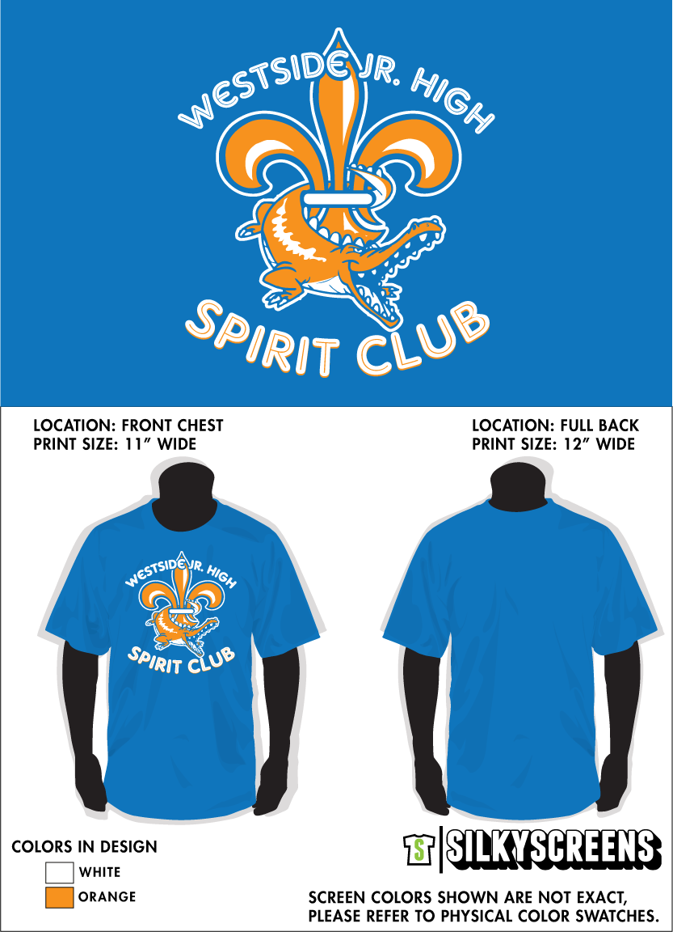
The shirts are orange with the Gator and Fleur de Lis in blue and white. The shirts are $15. Please make checks out to Westside Junior High. If you are ordering multiple shirts on one sheet please tell us number of each size you need. Thank you for your support of Westside Junior High.

